Individual Pathways
Activity 9.2
Investigating energy transmission

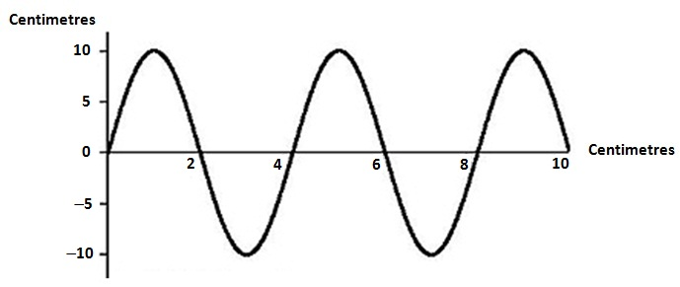

- What type of wave is shown in the diagram above? ..........................................................
- What is the wave’s:
(i) wavelength ...................................................
(ii) amplitude? ..................................................
- Give an example of energy that travels in this type of wave.
.............................................................................................................................................

- Generally, the speed of sound through a material depends upon how close together the particles of that material are and how elastic it is. The greater the ease with which collisions between particles (which transfer kinetic energy) can occur, the faster a sound wave can travel through the material. The following table gives you the speed at which sound waves travel through a variety of materials.

Material | Speed of sound (m/s)
Air (0 °C) | 331
Air (20 °C) | 344
Water (pure) | 1498
Sea water | 1540
Alcohol | 1207
Blood (37 °C) | 1570
Body tissue (37 °C) | 1570
Aluminium | 5100
Copper | 3900
Concrete | 4500
Granite | 5000
Lead | 1960
Glass (Pyrex) | 5170
Iron | 5120
Steel | 4700–6000  (average 5400)
Wood | 4000–5300

- Looking at the values in this table, what generalisation can you make about the speed of sound in liquids compared to its speed in solids and in gases?
....................................................................................................................................................................................................................................................................................................................................................................................................................................
- The wavelength (in metres) of a sound wave as it moves through any material depends upon its frequency (in hertz) and its speed in that material. This relationship can be represented by the equation (wavelength) = (speed) ÷ (frequency). Use this equation to calculate the wavelength of a sound wave that has a frequency of 150 Hz as it passes through copper.
....................................................................................................................................................................................................................................................................................................................................................................................................................................
- In movies you may see someone trying to tell if a train is coming by pressing their ear against the steel rail of the train track. Explain why this would be any better than just trying to hear the sound of the train coming through the air.
....................................................................................................................................................................................................................................................................................................................................................................................................................................
- Insert the following words into the diagram of the auditory system below.

Cochlea | Eustachian tube | Ear drum
Auricle | Auditory nerve | Ear canal

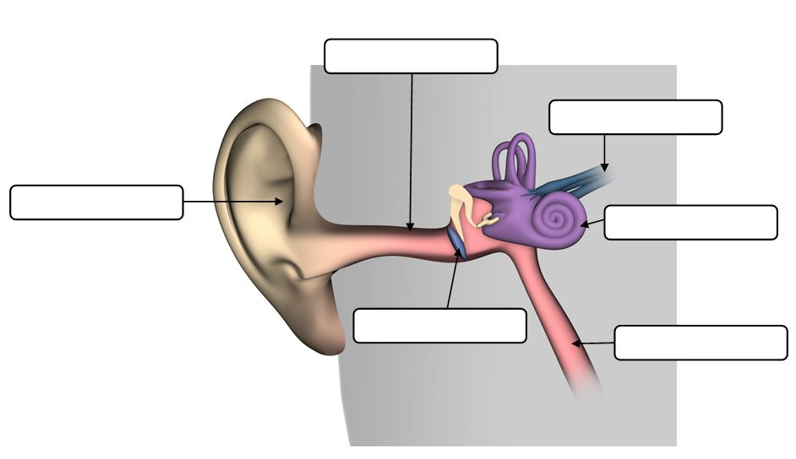

- Complete the table below by placing one of the types of electromagnetic waves next to its description:

Visible light | Radio waves | X-rays | Ultraviolet radiation

Type of electromagnetic wave | Description
 | Invisible to the human eye. The body needs it to form vitamin D but too much can give you a sunburn.
 | Used to form images that show what’s under your skin. It can also be used to kill cancer cells and detect flaws in metal components.
 | Necessary for our sense of sight and for plants to perform photosynthesis. It is only a very small section of the electromagnetic spectrum.
 | These are low-energy waves used to communicate over long distances. They include radar and microwaves.
- For each of the diagrams below, draw the path of the light beams that would result.
(a) (b)
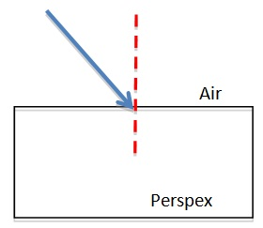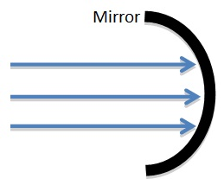

- Explain why people who have normal vision for much of their life may need glasses as they grow older.
................................................................................................................................................................................................................................................................................................................................................................................................................................................................................................................................................................................

- At the moment, we are in the process of changing over from analogue TV signals to digital TV signals. Give at least two advantages that digital TV will have over analogue TV.
................................................................................................................................................................................................................................................................................................................................................................................................................................................................................................................................................................................

- Explain how visible light is used to transmit phone calls along optical fibres. You may use diagrams to help you in your explanation if you wish.
................................................................................................................................................................................................................................................................................................................................................................................................................................................................................................................................................................................

Answers

- Transverse wave

(i) 4 cm
(ii) 10 cm
- Examples may include electromagnetic radiation/light or ocean waves.

2.
- The speed of sound in liquids is higher than it is in gases, but is slower than its speed in solids.
- Wavelength = speed/frequency = 3900/150 = 26 m
- The speed of sound in steel is about 5400 m/s, compared to 344 m/s in air. This means that the sound of the train’s approach can be heard through the track long before you would hear it through the air.

3.
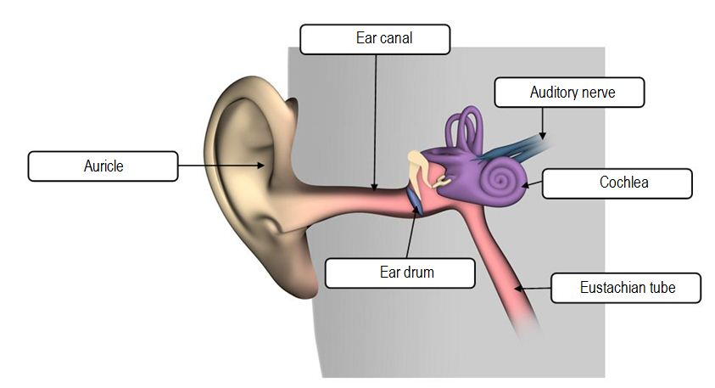

4.
Type of electromagnetic wave | Description
Ultraviolet radiation | Invisible to the human eye. The body needs it to form vitamin D but too much can give you a sunburn.
X-rays | Used to form images that show what’s under your skin. It can also be used to kill cancer cells and detect flaws in metal components.
Visible light | Necessary for our sense of sight and for plants to perform photosynthesis. It is only a very small section of the electromagnetic spectrum.
Radio waves | These are low-energy waves used to communicate over long distances. They include radar and microwaves.

5.
(a) (b)
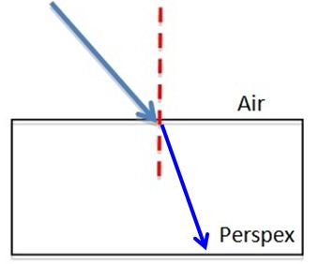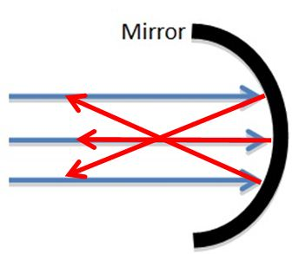

- As people get older, the lens gets more rigid and the ciliary muscles become weaker. This means that the lens is unable to make the bulgier shape required if the person is to form a focussed image of a close object on their retina. Instead, the image tries to form beyond the retina, resulting in a blurry image. To correct this condition (presbyopia), spectacles with converging lenses are needed to help focus the image on the retina. Bifocals — which only have converging lenses in the bottom half — allow the wearer to focus on near objects with correction and to view distant objects without correction.

- Responses may include two of the following.
- Sharper images
- Better sound quality
- Access to internet and email onscreen
- Capability of surround sound option
- Capability of interactive TV options
- Ability to access electronic program guides

- Sound energy is converted into electrical energy. Electrical signals are then converted into pulses of light, which are transmitted along the optical fibres. As the light approaches the outer cladding of the fibre, it bends so much that it is reflected back into the fibre. Therefore, the light is ‘trapped’ inside the fibre.

